**Yinghui Qiang 19692**

**MATH201 - Calculus-I**

**Homework Assignment #2**

**Due day: 6/10/2023**

1. Plot each following group of functions in one graph respectively by **Excel**, covering the appropriate domain of *x* and *y.*

ANS:



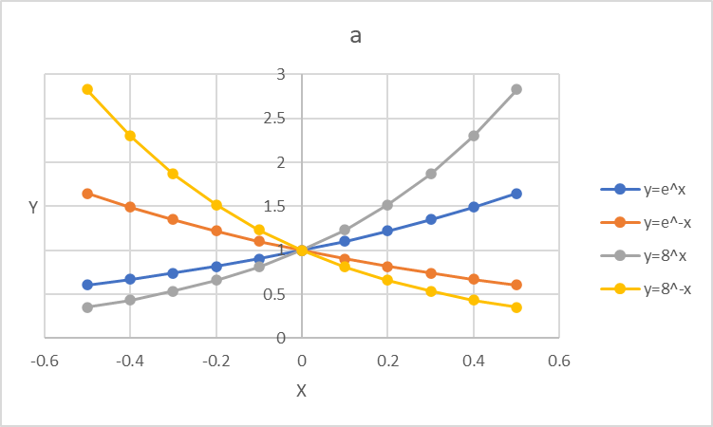

x [-0.5,0.5]

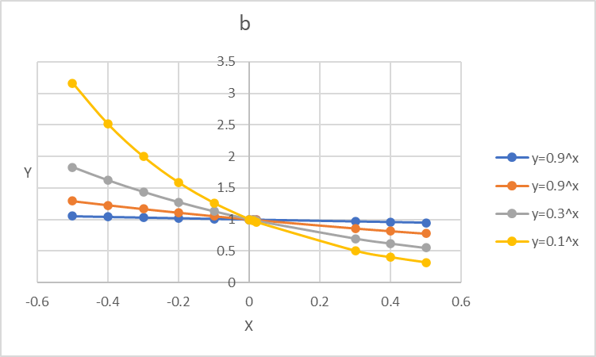

x [-0.5,0.5]

1. Given , prove that and verify it by the plot in **Excel.**

ANS:

Since f(x) = 10x f (x+h) = 10x+h =10x ×10h

= = = = 10x

x h

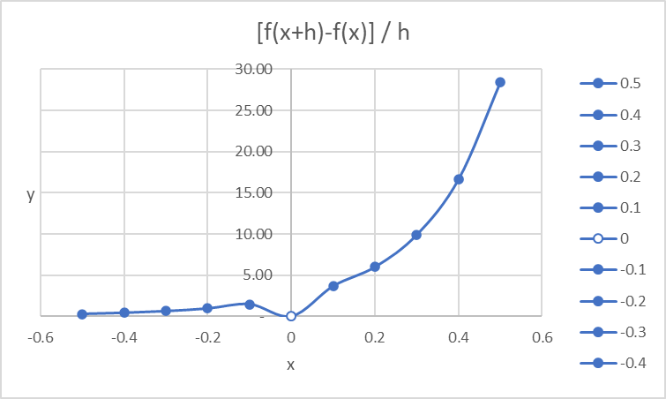

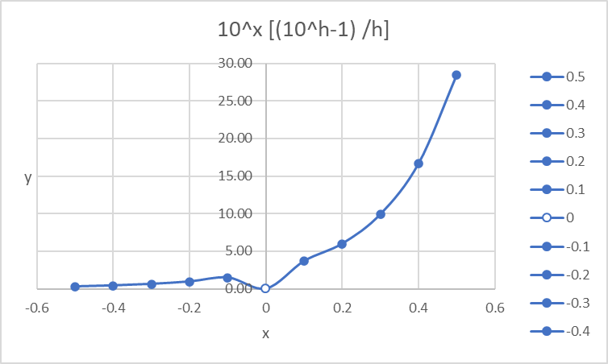

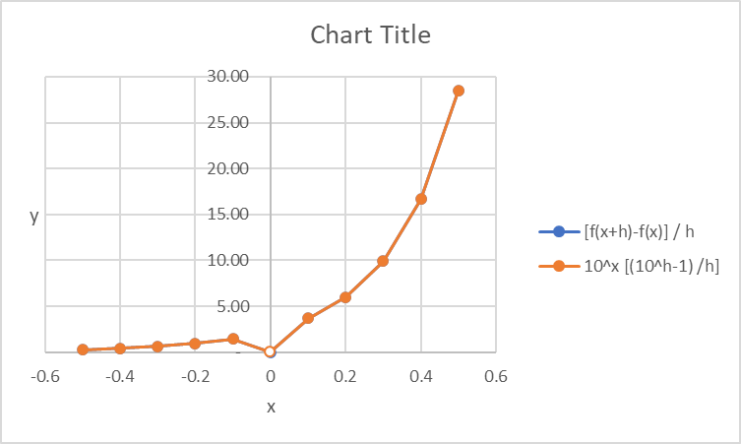

1. Compare the functions and by plotting curve in **Excel** and which function grows more rapidly when *x* is large? And prove it mathematically.

ANS:

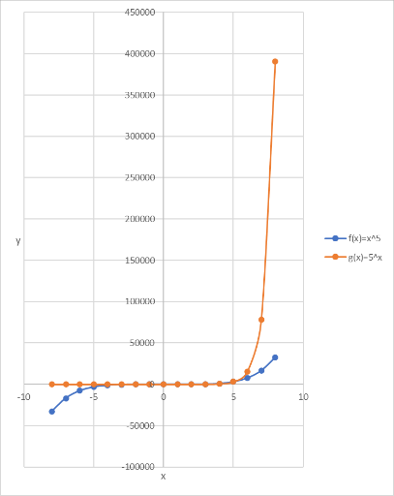 x

When x is large, g(x)=5^x grows more rapidly.

When x = 6 f(x)=x^5 = 6^5 = 7,776 g(x)=5^x= 5^6 = 15,625

When x = 8 f(x)=x^5 = 8^5 = 32,768 g(x) = 5^x = 5^8 = 390,625

1. Plot the function  in **Excel**. And then prove that is an odd function.

ANS:

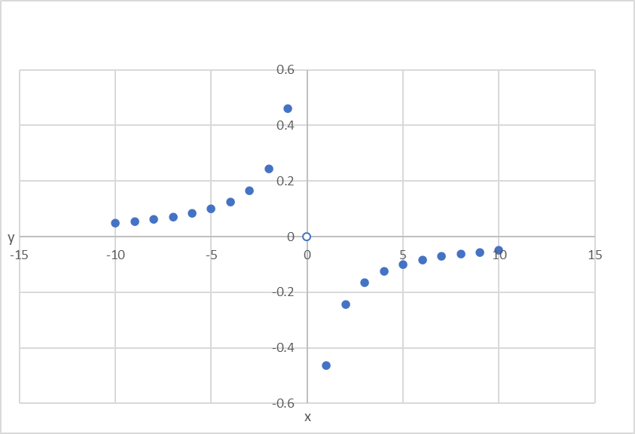

x

When f(-x) = -f(x), f is an odd function.

Since f(-x) =

*since* =

1. = = = =

= = = =

= =

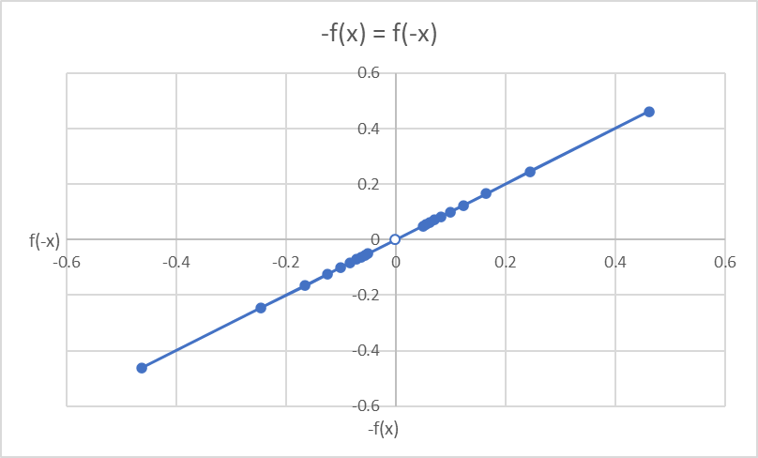

x

1. For the parametrized function

ANS:

* 1. where a > 0. How does the graph change when b changes by showing a group of curves by **Excel**?

Where a> 0 , when b changes, graph show as below:

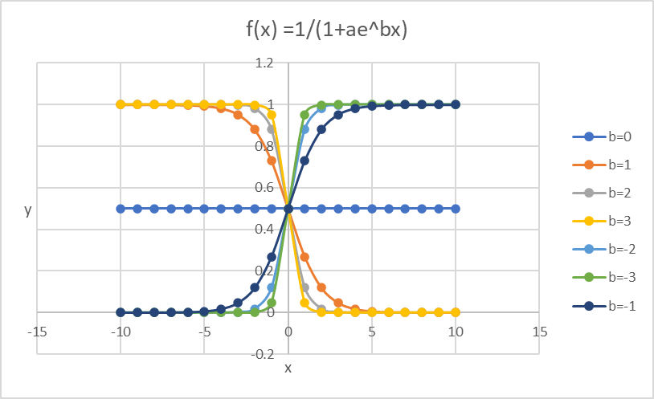

a>0, b  x

* 1. How does it change when *a* changes in **Excel**?

When a changes, graph show as below:

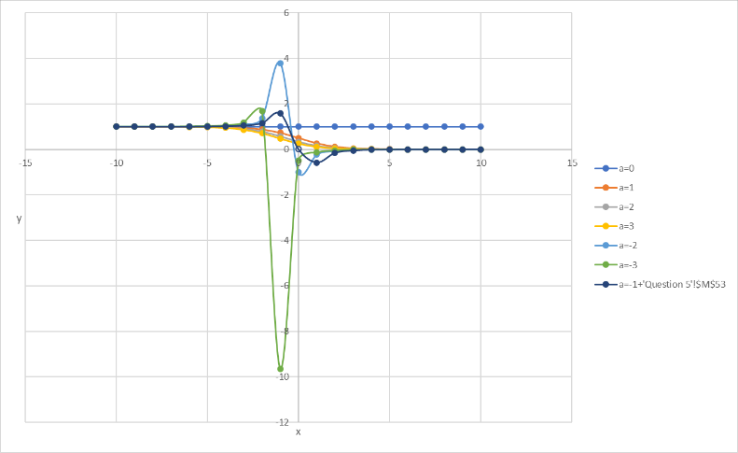

a x b=1

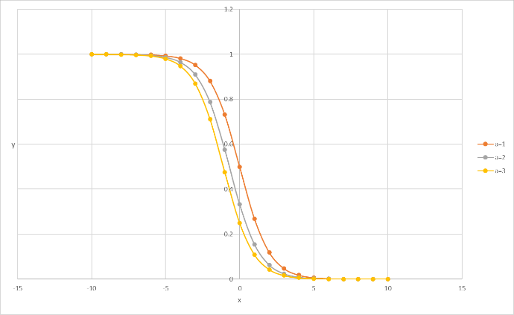

a>0 x b=1

1. If , find expression. And that, plot and in one graph by **Excel**

ANS:

= g-1 ( x6+x4) = x

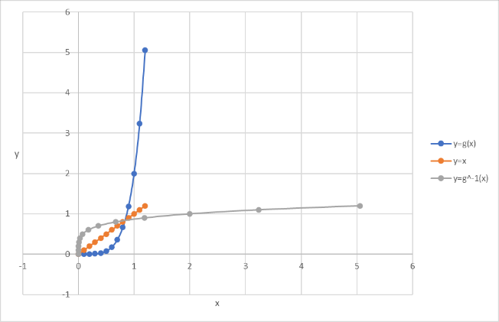

x

1. When a camera flash goes off, the batteries immediately begin to recharge the flash’s capacitor, which stores electric charge given by

(The maximum charge capacity is and t is measured in seconds.)

ANS:

1. Find the inverse of this function and explain its meaning.

The inverse of this function is: Qo -1 = t

Explanation:

Since the inverse function of f(y)=x is f-1(x) = y

X= t, Y= f(x) = Qo -1

t is the independent variable, and Qo is the dependent variable.

Which give the time t to calculate the recharge capacitor, Q. When the battereis

is full at 100%, it reach to Qo.

Inverse function means reverse the rols of t and Qo, and it become:

Qo -1 = t

Qo becomes the independent variable, and t becomes the dependent variable.

Which give the recharge capacitor Q, to calculate the charging time t. When

the battery charge is full at 100%, it reach to Qo.

1. How long does it take to recharge the capacitor to 90% of capacity if a = 2 showing in the plot by **Excel**?

Q(t)= 0.9 = 1- e (-t/a)

e (-t/a) = 1-0.9 = 0.1

(1/ e) (t/a) =0.1

e (-t/a) = 1/0.1=10

since a = 2, et = 102

t = = 4.6 sec

It will take 4.6 second to recharge to 90% of capacity if a=2.

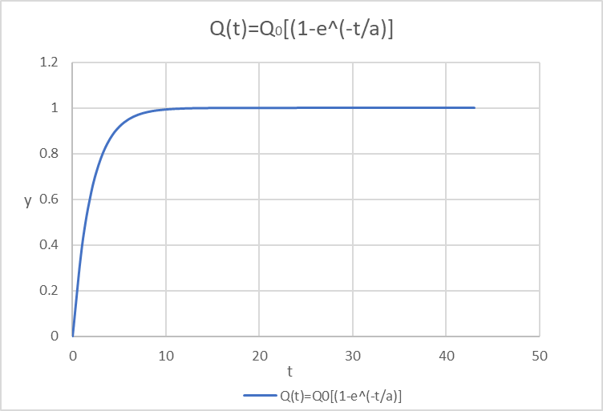 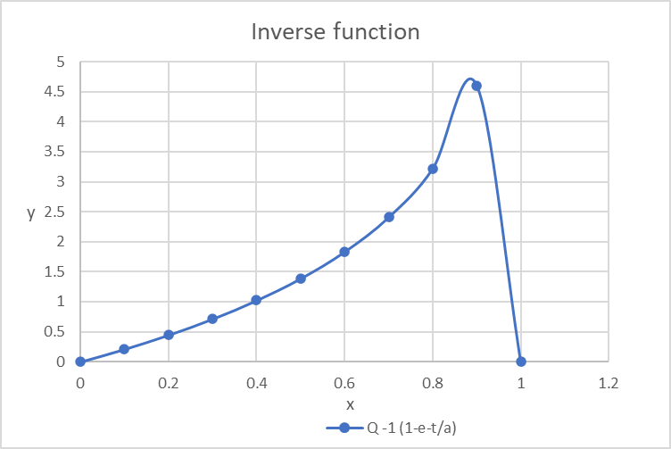

t Q

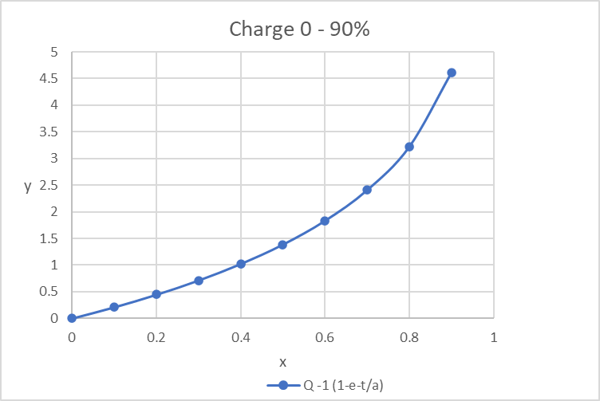

Q